|  |  |
| --- | --- |
| AutoML Modeling Report |  |

#### *Chromilo Amin | Thursday, December 15, 2020 | Bertelsmann Technology Scholarship program*

Binary Classifier with Clean/Balanced Data

|  |  |
| --- | --- |
| **Train/Test Split**  How much data was used for training? How much data was used for testing? | 100 images for normal and 100 images for pneumonia images were used for training. |
| **Confusion Matrix**  What do each of the cells in the confusion matrix describe? What values did you observe (include a screenshot)? What is the true positive rate for the “pneumonia” class? What is the false positive rate for the “normal” class? |  |
| **Precision and Recall**  What does precision measure? What does recall measure? What precision and recall did the model achieve (report the values for a score threshold of 0.5)? |  |
| **Score Threshold**  When you increase the threshold what happens to precision? What happens to recall? Why? |  |

Binary Classifier with Clean/Unbalanced Data

|  |  |
| --- | --- |
| **Train/Test Split**  How much data was used for training? How much data was used for testing? |  |
| **Confusion Matrix**  How has the confusion matrix been affected by the unbalanced data? Include a screenshot of the new confusion matrix. |  |
| **Precision and Recall**  How have the model’s precision and recall been affected by the unbalanced data (report the values for a score threshold of 0.5)? |  |
| **Unbalanced Classes**  From what you have observed, how do unbalanced classed affect a machine learning model? |  |

Binary Classifier with Dirty/Balanced Data

|  |  |
| --- | --- |
| **Confusion Matrix**  How has the confusion matrix been affected by the dirty data? Include a screenshot of the new confusion matrix. |  |
| **Precision and Recall**  How have the model’s precision and recall been affected by the dirty data (report the values for a score threshold of 0.5)? Of the binary classifiers, which has the highest precision? Which has the highest recall? |  |
| **Dirty Data**  From what you have observed, how does dirty data affect a machine learning model? |  |

3-Class Model

|  |  |
| --- | --- |
| **Confusion Matrix**  Summarize the 3-class confusion matrix. Which classes is the model most likely to confuse? Which class(es) is the model most likely to get right? Why might you do to try to remedy the model’s “confusion”? Include a screenshot of the new confusion matrix. |  |
| **Precision and Recall**  What are the model’s precision and recall? How are these values calculated (report the values for a score threshold of 0.5)? |  |
| **F1 Score**  What is this model’s F1 score? |  |

Appendix – GCP AutoML Vision Classifier Test dataset

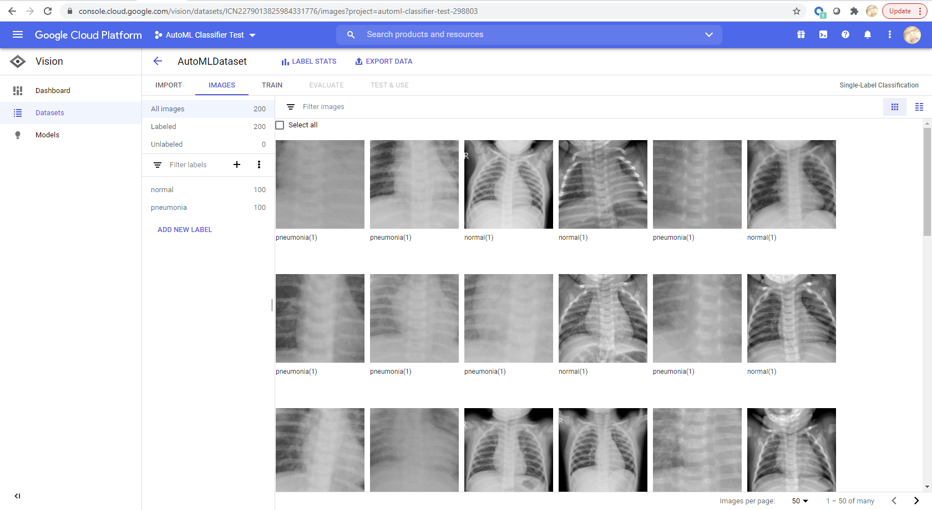

Appendix – GCP Cloud Storage

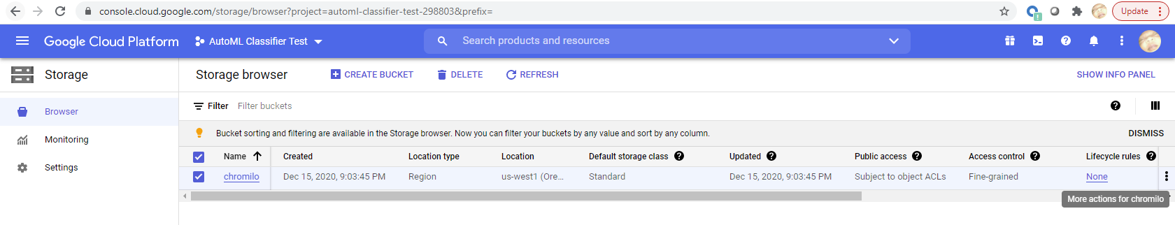

Appendix – GCP AutoML Vision | Train

